Algorithm:



Code:

*a = int(input("enter first no.: "))*

*b = int(input("enter second no.: "))*

*print("Addition:", a+b)*

*print("subtraction: ", a-b) print("multiplication:", a*b) print("divsion:", a/b)*

*print("module:", a%b)*

print("floor division:", a//b) print("exponentiation:",a ** b)

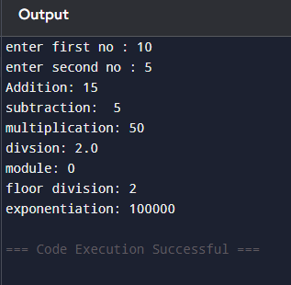

Result:

# Algorithm:



**Code:**

*a = int(input("enter first no .: "))*

*b = int(input("enter second no: "))*

*print("a == b:", a == b)*

*print("a != b:",a != b)*

*print("a>b:",a>b)*

*print("a<b:",a<b)*

*print("a>=b:",a>=b)*

print("a <= b:",a <= b)

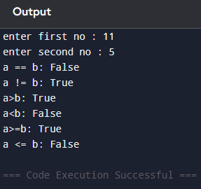

Result:

Aim:

Algorithm:



Code:

*a = (int(input("Enter a : ")))*

*b = bool(int(input("Enter b : ")))*

*print("a>5 and b<5:", a>5 and*

*b<5 )*

*print("a or b:", a>15 or b<15) print(" not(b<5):", not( b<5))*

Output:

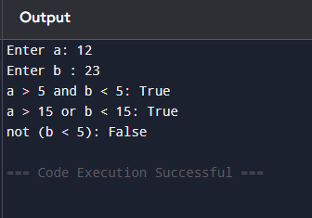

Result:

Aim:

Algorithm:



Code:

*a = int(input("enter first no .: "))*

*b = int(input("enter second no : "))*

*c=a*

*print("a is b:", a is b)*

*print("a is c:", a is c) print("a is not b:", a is not b)*

Output:

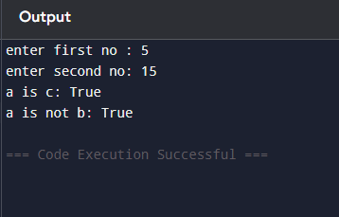

Result:

Aim:



Algorithm:

Code:

*a = float(input("Enter first number: "))*

*b = float(input("Enter second number: "))*

*c = float(input("Enter third number: "))*

average = (a + b + c) / 3

print("Average of the three numbers is:", average)

Output:

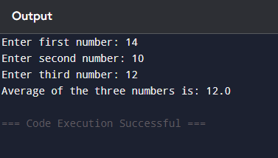

Result:

Aim:

Algorithm:



Code:

*weight = float(input("Enter weight in kg: "))*

*height = float(input("Enter height in meters: "))*

*bmi = weight / (height ** 2)*

*print("Your BMI is:", bmi)*

Output:

Result:

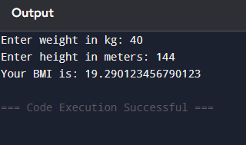

Aim:

Algorithm:

# Code:

a = 5 b=14

print(" value of a Before swapping:",a) print("value of b berfore swapping:",b)

temp=1 temp=a a=b b=temp

print("value of a after swapping:",a) print("value of b after swapping:",b**)**

Output:

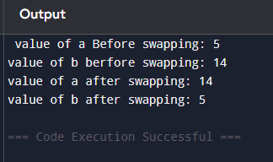

Result:

Aim:

Algorithm:

***Code:***

length = float(input("Enter the length of the rectangle: ")) breadth = float(input("Enter the breadth of the rectangle: ")) area = length * breadth

print("Area of the rectangle:", area)

Output:

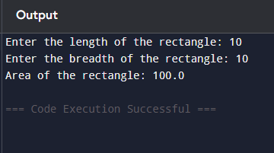

Result:

Aim:

Algorithm:



Code:

*import math*

*num = float(input("Enter a number: ")) sqrt = math.sqrt(num)*

*print("Square root of", num, "is", sqrt)*

Output:

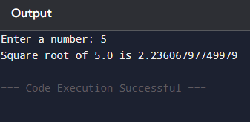



Result:

Aim:

Algorithm:



Code:

*base = float(input("Enter the base of the triangle: ")) height = float(input("Enter the height of the triangle: ")) area = 0.5 * base * height*

*print("Area of the triangle:", area)*

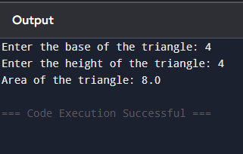

Result:

Aim:

Algorithm:



Code:

*km_to_miles = 0.621371*

*kilometers = float(input("Enter distance in kilometers: ")) miles = kilometers * km_to_miles*

*print(f"{kilometers} kilometers is equal to {miles} miles.")*

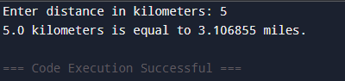



Result:

Algorithm:



Code:

*celsius = float(input("Enter temperature in Celsius: "))*

*fahrenheit = (celsius * 9/5) + 32 print(f"{celsius}°C is equal to {fahrenheit}°F")*

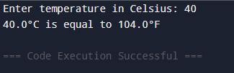



Result:

Algorithm:

*"))*



Code:

*principal = float(input("Enter the principal amount:*

*rate = float(input("Enter the rate of interest (%): ")) time = float(input("Enter the time (in years): ")) simple_interest = (principal * rate * time) / 100*

*print("Simple Interest is:", simple_interest)*

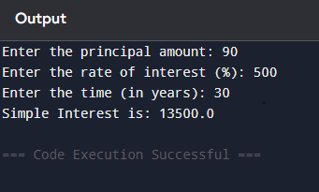

Result:

Aim:

Algorithm:

Code:

import math

radius = float(input("Enter the radius of the circle: ")) area = math.pi * radius ** 2

print(f"Area of the circle with radius {radius} is {area}")

Output:

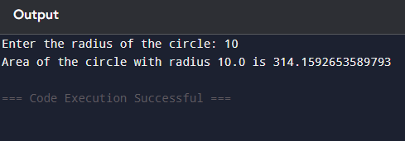

Result: